THE JEFFERY ALLAN BURGIN
SCHOLARSHIP

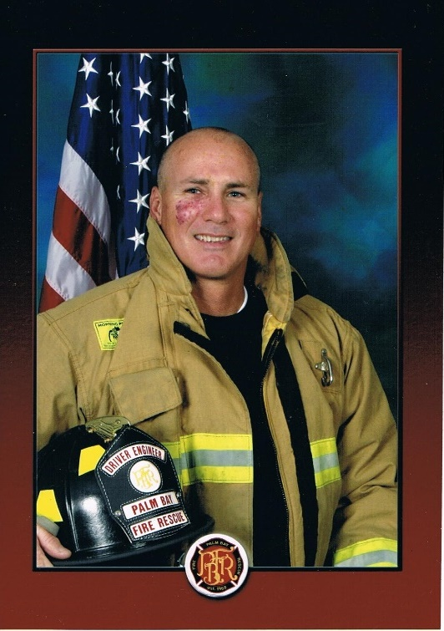
February 26, 1962 – JUNE 20, 2012

The Palm Bay Firefighters Community Benevolent, Inc. and the Family of Jeff Burgin, have established this Scholarship to honor Jeff’s memory. Jeff served three (3) years with the Florida Forestry Service as a Firefighter and sixteen (16) years as a Firefighter with the City of Palm Bay Fire Department. He was a Driver/Engineer, Paramedic, and was posthumously promoted to Fire Lieutenant.

DEADLINE TO APPLY FOR THE FALL/2019 SCHOLARSHIP IS WEDNESDAY, JULY 31, 2019
(Applications must be received by the deadline date)
THE JEFFERY ALLAN BURGIN SCHOLARSHIP is available for students planning to attend Eastern Florida State College (EFSC) and pursue a career in the fire service as a Firefighter.
Amount of Scholarship:
The Jeffery Allan Burgin Scholarship will be awarded twice a year to coincide with the Fall and Spring Fire Academy at EFSC. The maximum amount for each scholarship is $1,250.00.
Eligibility:
An eligible student must be a Brevard County resident for one (1) year. Applicants must meet Eastern Florida State College admission requirements (in-state) and Florida Bureau of Fire Standards and Training Requirements.
Basis of Awards:
Applicants must indicate financial need, aptitude promise and demonstrate academic achievement. Applicants must provide a transcript of grades along with a letter of recommendation from two persons. Applicants must provide a brief statement (about 250 words) indicting their reasons for pursuing a career as a Firefighter.
Applications should be mailed to:
Selection Committee, Palm Bay Firefighters Community Benevolent Fund, 1465 Georgia Street, N.E., Unit B, Palm Bay, FL 32907. Applications must be received by the deadline date. Please allow sufficient time for mail delivery.
Scholarship inquiries should be directed to:
District Chief Brian Gent, Scholarship Committee Chairman, Palm Bay Firefighters Community Benevolent Fund, secretary@iaff2446.com, or by mail to 1465 Georgia Street, N.E., Unit B. Palm Bay, FL 32907.
Due:
Application due date is posted on the cover sheet. Application must be received by the deadline date. Please allow sufficient time for mailing. Official announcement of the winner will be made by the Selection Committee of the Palm Bay Firefighters Community Benevolent Fund. All applicants will be notified of the results of the Selection Committee.

THE JEFFERY ALLAN BURGIN SCHOLARSHIP:

Rules and Regulations

Purpose:

The purpose of the Jeffery Allan Burgin Scholarship is to provide financial assistance for an applicant pursuing a career in the fire service as a Firefighter.

Application information:

All applications for the Jeffery Allan Burgin Scholarship should be directed to: Selection Committee, Palm Bay Firefighters Community Benevolent Fund, 1465 Georgia Street, N.E., Unit B., Palm Bay, FL 32907.

Scholarship Application Information:

I. Scholarship Awards

A. The Jeffery Allan Burgin Scholarship will be awarded twice a year to coincide with the Fall and Spring Fire Academy.

B. Scholarship awards will be made on or about August 1st , for the Fall Academy and February 1st, for the Spring Academy.

C. Scholarship recipients will be notified by letter from the Selection Committee of the Palm Bay Firefighters Community Benevolent Fund.

D. A scholarship recipient shall receive a maximum of one (1) scholarship.

II. Scholarship Application Process

A. All applications and supporting materials must be mailed to the Selection Committee, Palm Bay Firefighters Community Benevolent Fund and received no later than the date posted on the cover page. All applications and supporting materials will become the property of the Palm Bay Firefighters Community Benevolent Fund.

B. Scholarship applications and supporting materials received after the due date will be ineligible and returned to the applicant.
C. Application and supporting materials shall include:

1. A completed Jeffery Allan Burgin Scholarship Application Form.

2. An official copy of the school transcript and grade report from the school currently attended or most recently attended. The official school transcript should list all grade points earned and academic course work completed to date.

3. A brief statement (about 250 words) prepared by the applicant which indicates their reasons for wanting to pursue a career in the fire service as a Firefighter.

4. Two letters of recommendation.

a. Letters of recommendation should be from a person that has knowledge of the applicant’s qualifications, academic aptitude, and character.

b. The required letters of recommendation may not be from immediate family members, close family friends, blood relatives, or relationships by marriage.

D. A letter from Eastern Florida State College Fire Academy stating the applicant meets EFSC admission requirements for P.S.A.V. and Florida Bureau of Fire Standards and Training Requirements. Conditional Letter is acceptable for applying and final acceptance letter will be required prior to disbursement of funds.

E. All applicants submitting a scholarship application and supporting materials are required to satisfy all application process requirements.

F. Applicant may be required to submit proof of family income.

III. Educational Institution

A. The Jeffery Allan Burgin Scholarship is limited to those applicants attending the Eastern Florida State College Fire Academy.

IV. Scholarship award disbursement

A. Scholarship award money shall be deposited with the Eastern Florida State College Financial Aid Office.

B. The award money is credited to an account in the individual’s name to be drawn upon for:

1. Fees or charges required for tuition.

2. Expenses for text books, course work, lab fees and other materials as required by the Fire Academy.

C. Scholarship awards are not transferable to another individual or institution and are forfeited by the recipient upon withdrawal from the Eastern Florida State College Fire Academy where the scholarship award was disbursed by the Palm Bay Firefighters Benevolent Fund or upon failure to meet the institution’s appropriate standards of academic achievement, conduct or character.

D. In the event a scholarship recipient’s educational endeavors are interrupted during the period of the scholarship award as a result of being called to active duty under Title 10 of the United States Code or National Guard Duty in State Statutes, the scholarship award money shall be held by the PBFFBF for a period of not more than twenty-four (24) months, unless the time for active duty is extended by the military authority.

1. It is the responsibility of the scholarship recipient to keep the Palm Bay Firefighters Benevolent Fund informed of their military status.

2. Any scholarship award recipient leaving the U.S. Armed Services or National Guard duty must reapply for reinstatement of the scholarship monies or the remaining portion of scholarship monies within ninety (90) days after severance from duty.

V. Scholarship selection criteria

A. The primary selection criteria is the need for financial assistance by the applicant. Financial need is based upon the current total family income along with other scholarships and financial assistance available to the applicant.

B. Scholarship recipient will be selected based upon previous academic performance (high school grades for new college entrants and cumulative college grade point average and academic performance for college applicants). A minimum satisfactory academic performance of a C grade (2.5 on a 4.0 scale) is required for all scholarship recipients.

C. The applicant’s statement (about 250 words) indicating their reasons for wanting to pursue a career in the fire service as a Firefighter will be considered to help identify the applicant’s financial need, as well as the applicant’s educational and career goals.

D. The accompanying letters of recommendation will be considered to help determine the applicant’s aptitude promise and character.

E. Applications will be reviewed by the Selection Committee appointed by the Palm Bay Firefighters Community Benevolent, Inc.

F. All scholarship awards are final and must be used for the Academy Class applied for or the scholarship will be forfeited.

JEFFERY A. BURGIN SCHOLARSHIP APPLICATION _________________________
Indicate Academy Class and EFSC Student #

Name _______________________________________________________________________________________
Last Name First Name Initial

Address ______________________________________________________________________________________ Street

_____________________________________________________________________________________________________________________
City County State Zip Code

Phone (_____)________________ Social Security #_____________________ Date of Birth__________________
Area Code
How many in family___________? List names and ages of members of the family________________________________________________________________________________________

_____________________________________________________________________________________________

_____________________________________________________________________________________________

Total annual family income $______________________ Date living in Brevard County__________________

Last school attended_____________________________________________________________________________
(Attach a certified Transcript)

List other scholarships which you have applied for and/or have received. Indicate name and scholarship amount._______________________________________________________________________________________

_____________________________________________________________________________________________

Please indicate all other financial assistance which you have received to date or will receive and the amount. _____________________________________________________________________________________________

_____________________________________________________________________________________________

Note: Applicant must furnish a certified transcript of grades with their application and attach recommendations from two persons giving a brief estimate of your scholastic ability, character and potential. Also attach a brief written (about 250 words) statement as to your reasons for pursuing a fire service career as a Firefighter.

I declare that the statements made in this application and all accompanying materials are true and complete to the best of my knowledge and belief. I understand that in the event that any information is found to be intentionally falsified I will be immediately disqualified from consideration for the scholarship.

_____________________________________________________________ _____________________
Signature of Applicant Date

Return completed application to Selection Committee, Palm Bay Firefighters Community Benevolent Fund, 1465 Georgia Street, N.E., Unit B, Palm Bay, FL 32907. Application must be received by the deadline date.

